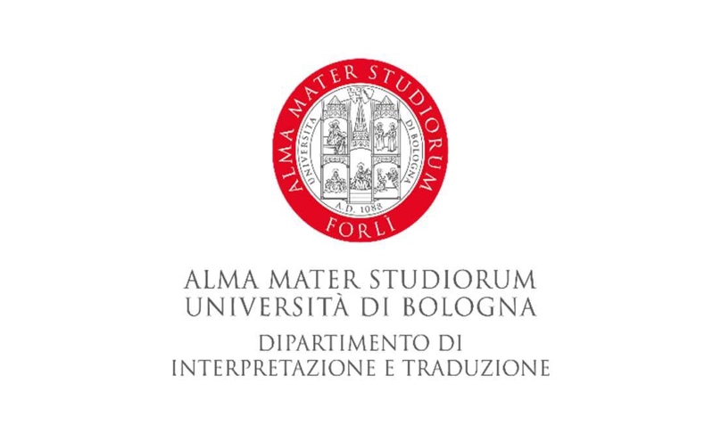
General document of the D.I.T. Internship Committee

Guidelines for trainees

The trainee must choose a 100-hours training activity in the field of linguistics and translation to be defined/planned with both the university Tutor and the company Tutor.

The trainee’s activity report will include the hours devoted to any activity which is preliminary and collateral to the training activity itself, for example:

- documentary and terminological research, creation/processing of glossaries, any phone call or consultation with experts, office work during which the trainee can practice the languages studied (for instance, email and fax translation, or phone calls with international clients);
- translation for the publishing industry: draft, translation and revision of texts;
- cultural-linguistic mediation in multilingual interactions;
- subtitling: dialogues spotting, subtitles creation, subtitles revision, production of .srt/.ass files, subtitles hand-operated launch;
- journalism: texts drafting and revision in the publishing field; texts drafting and revision for press releases;
- educational activity in education centres or private/public language schools: activities may include teaching support such as support to teachers during school hours, planning of didactic programmes, school/class meetings, support in the planning of individual paths for pupils with learning difficulties (suffering from ASD, BES).

Guidelines for the company/institution/organization/education centre/school

As for the company/institution/association/organisation/education centre/school, they shall provide adequate assistance to the trainee with regard to all activities related to the internship (e.g. terminology and experts advice) and with any difficulties or problems which may arise, throughout the whole duration of their internship.
In addition, a most fruitful communication with the trainees must be committed to ensuring the development of any useful soft skills in the relevant working field.
It should also be noted that the final responsibility for the quality of the translation (or revision) into the mother tongue and/or foreign language remains with the organisation, whether it is intended for purely internal use or external use, for example for publication or marketing purpuses.
Finally, it should be noted that the internship activity is of a ‘professionalizing’ and not a ‘professional’ nature since students are still attending their degree course.

D.I.T. Internship Committee

